ReactJS - HQL OUTPPUTS

Name : G.S.R.Hemanth

Superset Id : 6124988

1. Create a React app.

**Step – 1 :** Check your node and react version. If not installed install them.

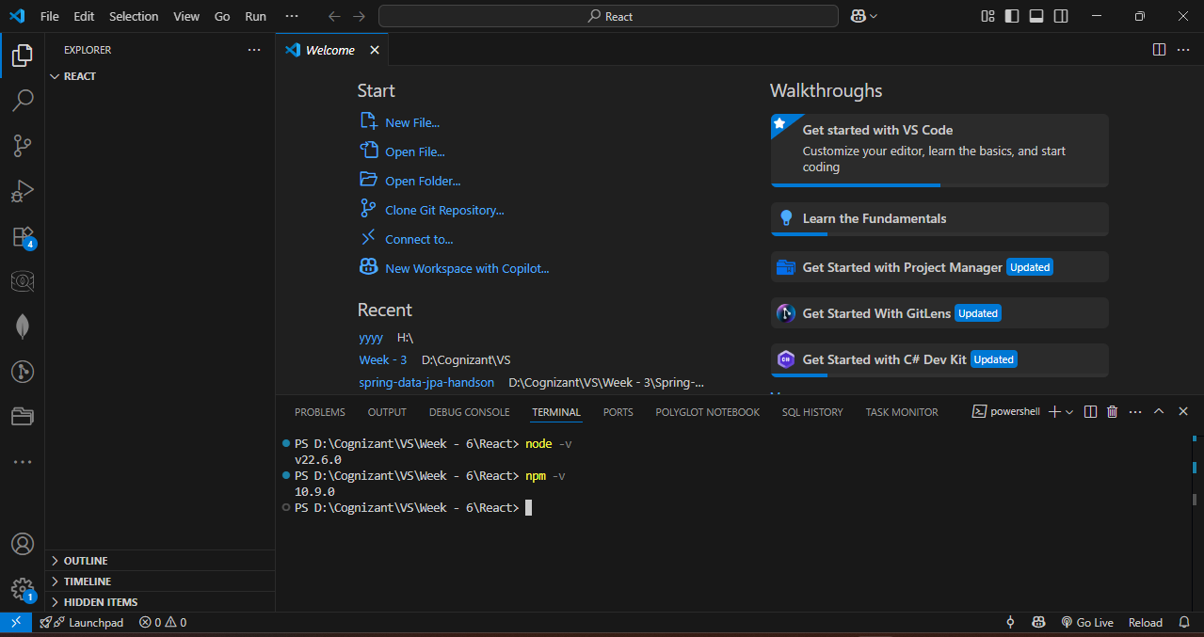

**Step – 2 :** Create a react app name it myfirstreact.

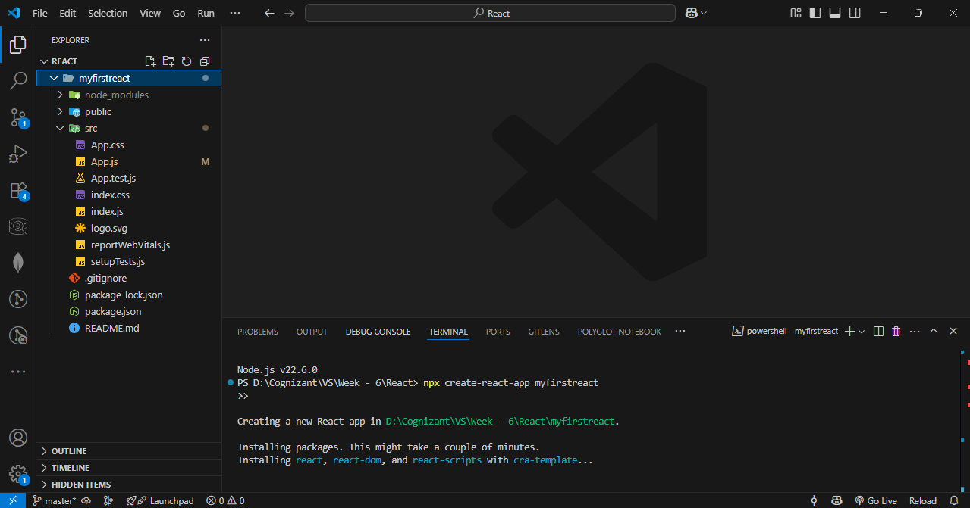

**Step – 3 :** Write code in app.js

**Code :**

import React from 'react';

function App() {

  return (

    <div>

      <h1>Welcome to the first session of React</h1>

    </div>

  );

}

export default App;

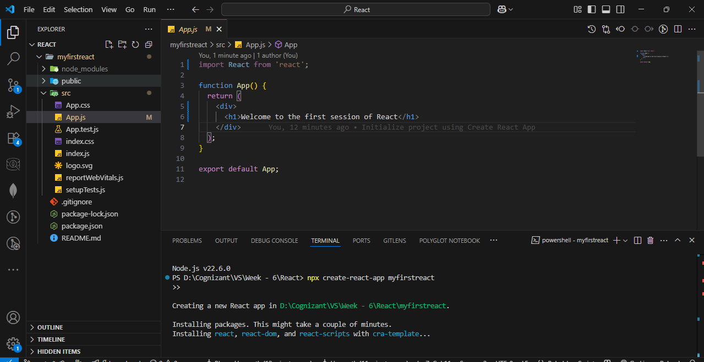

**Step – 4 :** Run the code.

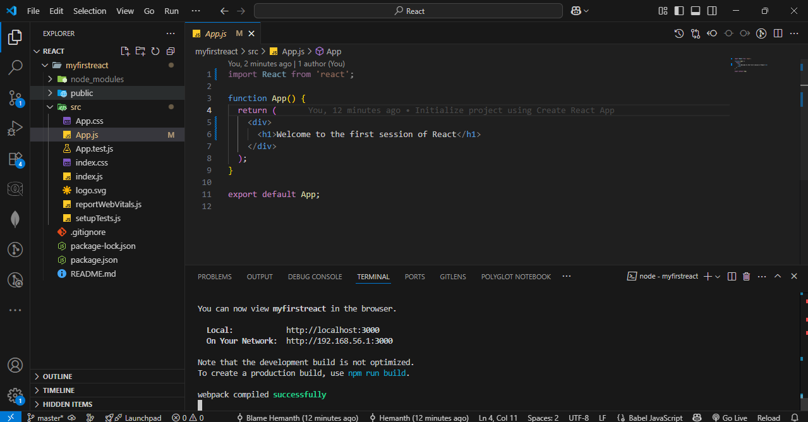

OUTPUT :

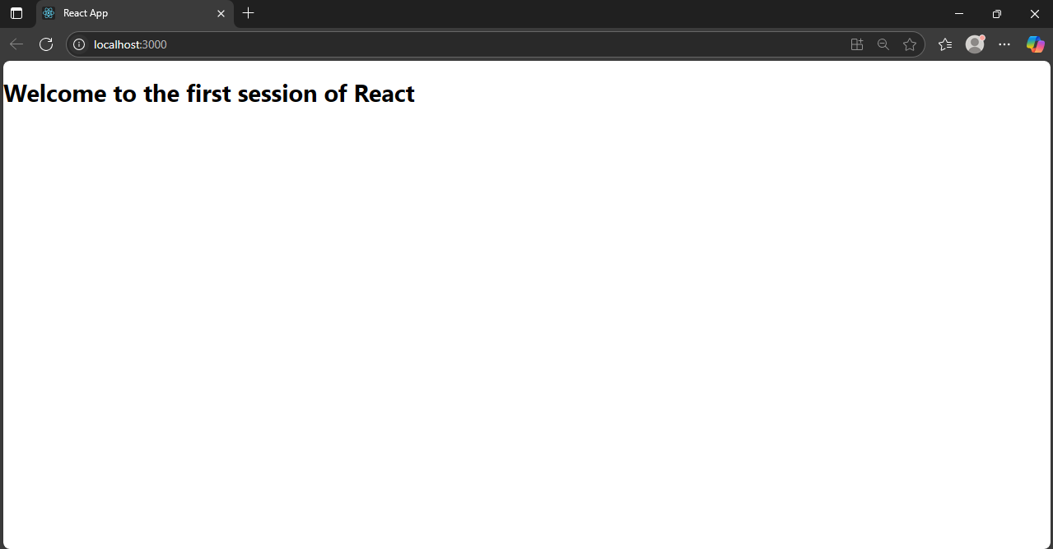

1. Student Management Portal

**Step – 1 :** Create a react app named StudentApp.

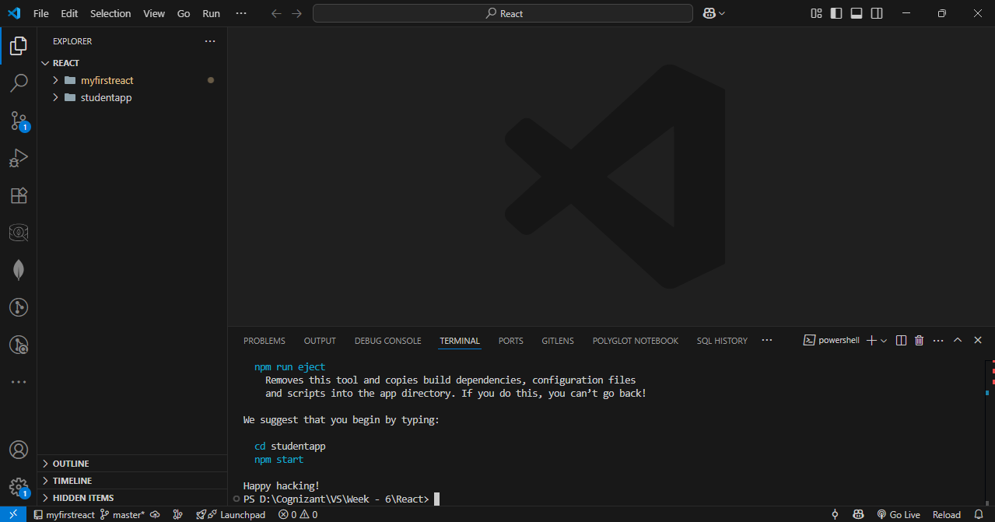

**Step – 2 :** Create three java classes Home.js, about.js and contact.js in src/components.

**Home.js Code :**

import React, { Component } from 'react';

class Home extends Component {

constructor(props) {

super(props);

}

render() {

return (

<div>

<h2>Welcome to the Home page of Student Management Portal</h2>

</div>

);

}

}export default Home;

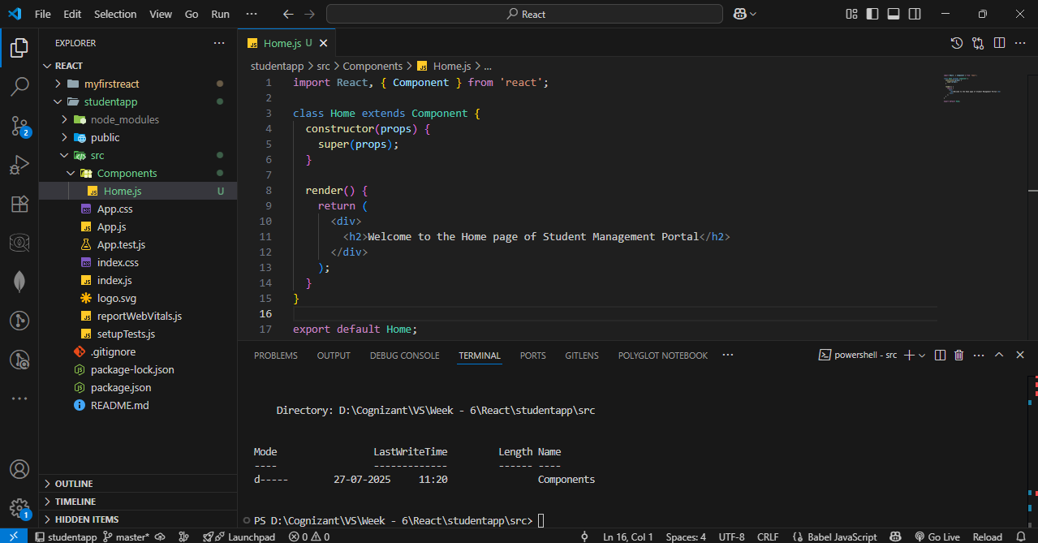

**About.js Code :**

import React, { Component } from 'react';

class About extends Component {

constructor(props) {

super(props);

}

render() {

return (

<div>

<h2>Welcome to the About page of the Student Management Portal</h2>

</div>

);

}

}

export default About;

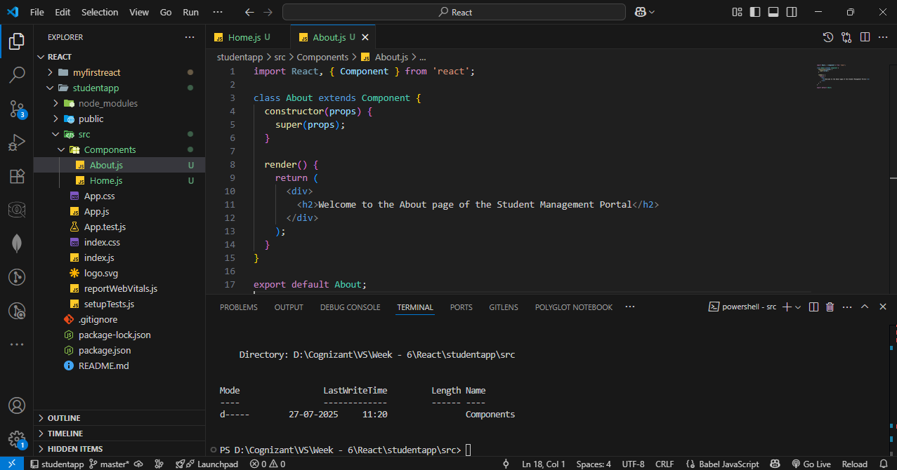

**Contact.js Code :**

import React, { Component } from 'react';

class Contact extends Component {

constructor(props) {

super(props);

}

render() {

return (

<div>

<h2>Welcome to the Contact page of the Student Management Portal</h2>

</div>

);

}

}

export default Contact;

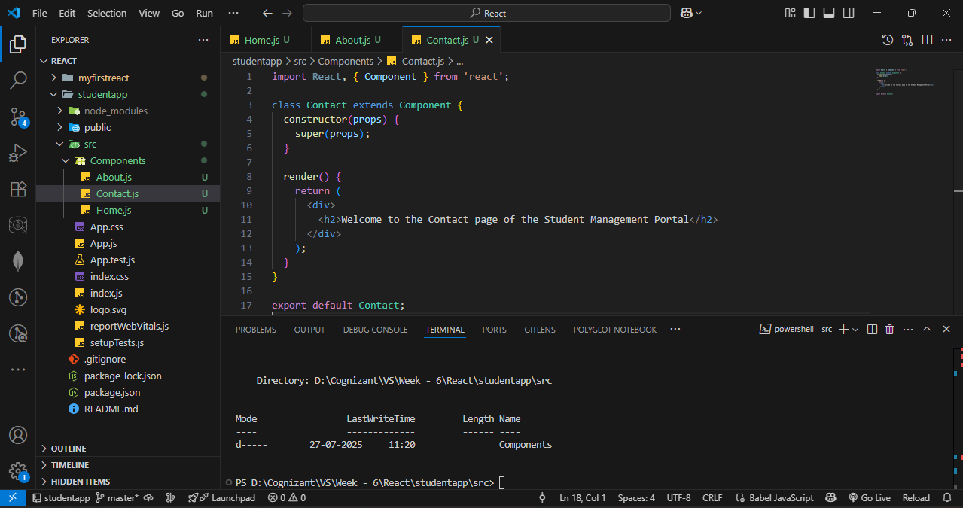

**Step – 3 :** Update App.js

**Code :**

import React from 'react';

import './App.css';

import Home from './Components/Home';

import About from './Components/About';

import Contact from './Components/Contact';

function App() {

return (

<div className="App">

<h1>Student Management Portal</h1>

<Home />

<About />

<Contact />

</div>

);}export default App;

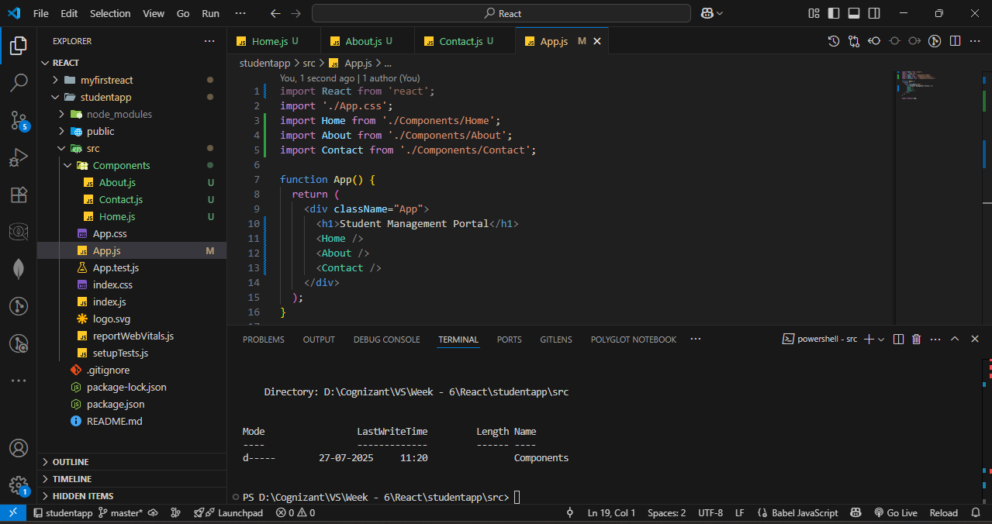

**Step – 4 :** Start the server.

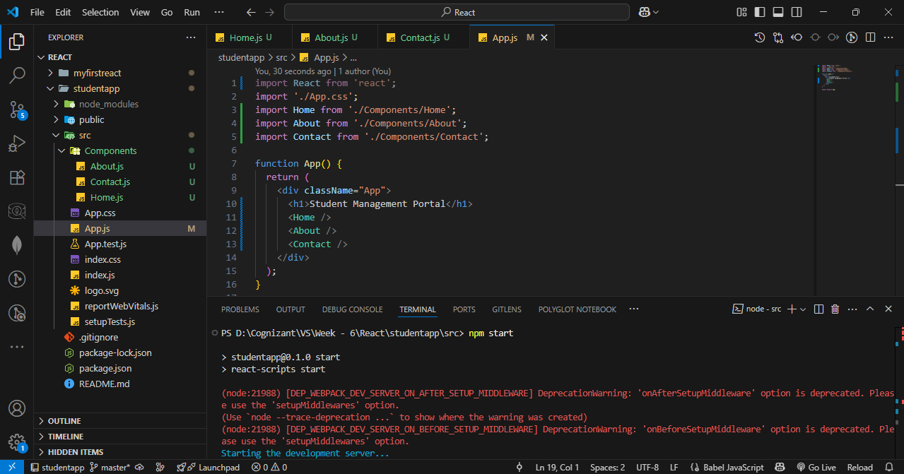

OUTPUT :

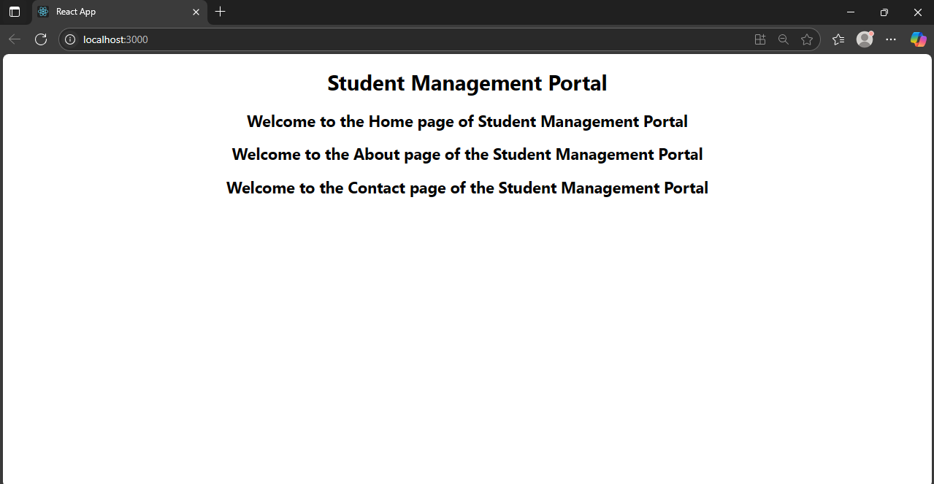

1. Score Calucator App

**Step – 1 :** Create a react app named scorecaluculator app.

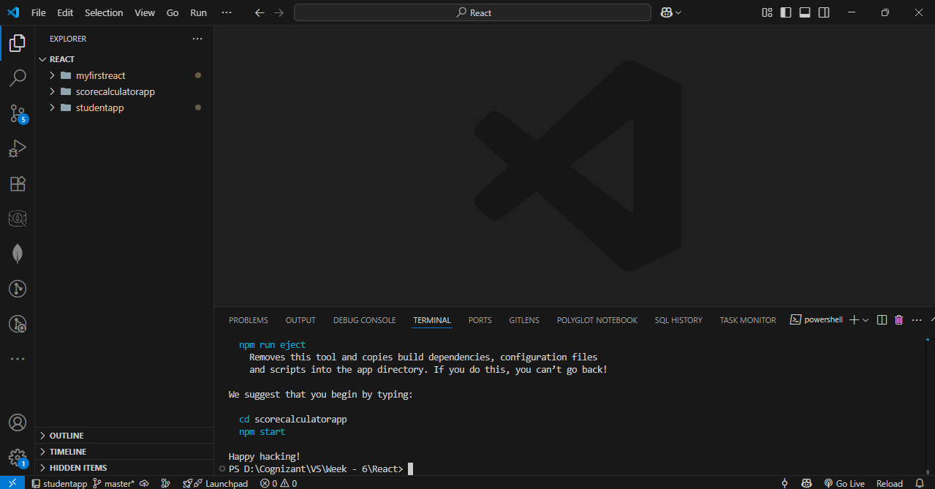

**Step – 2 :** Create a folder named components and create a CalculateScore.js file.

**Code :**

import '../Stylesheets/mystyle.css';

const percentToDecimal = (decimal) => {

  return (decimal.toFixed(2) + '%');

};

const calcScore = (total, goal) => {

  return percentToDecimal(total / goal);

};

export const CalculateScore = ({ Name, School, total, goal }) => (

  <div className="formatstyle">

    <h1><font color="Brown">Student Details:</font></h1>

    <div className="Name">

      <b><span> Name: </span></b>

      <span>{Name}</span>

    </div>

    <div className="School">

      <b><span> School: </span></b>

      <span>{School}</span>

    </div>

    <div className="Total">

      <b><span>Total:</span></b>

      <span>{total}</span>

      <span> Marks</span>

    </div>

    <div className="Score">

      <b>Score:</b>

      <span>

        {calcScore(total, goal)}

      </span>

    </div>

  </div>

);

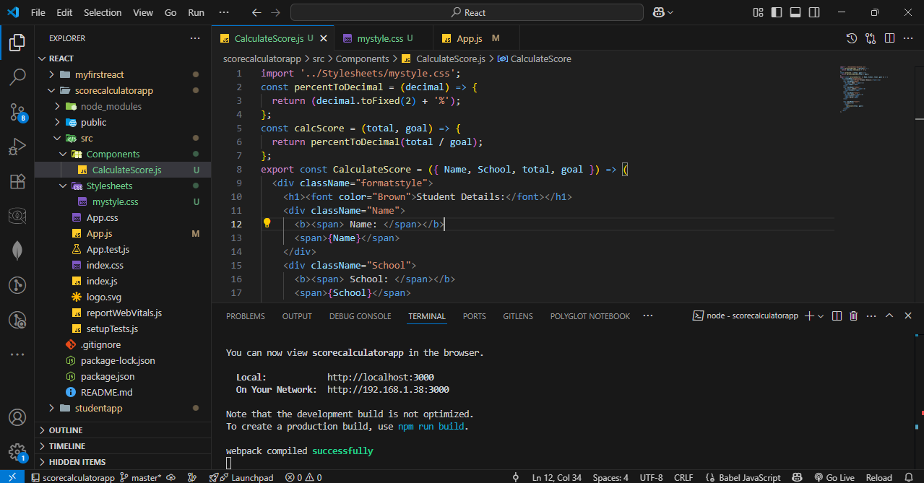

**Step – 3 :** Create a folder named Stylesheets and create mystyle.css.

**Code :**

.Name {

    font-weight: 300;

    color: blue;

}

.School {

    color: crimson;

}

.Total {

    color: darkmagenta;

}

.formatstyle {

    text-align: center;

    font-size: large;

}

.Score {

    color: forestgreen;

}

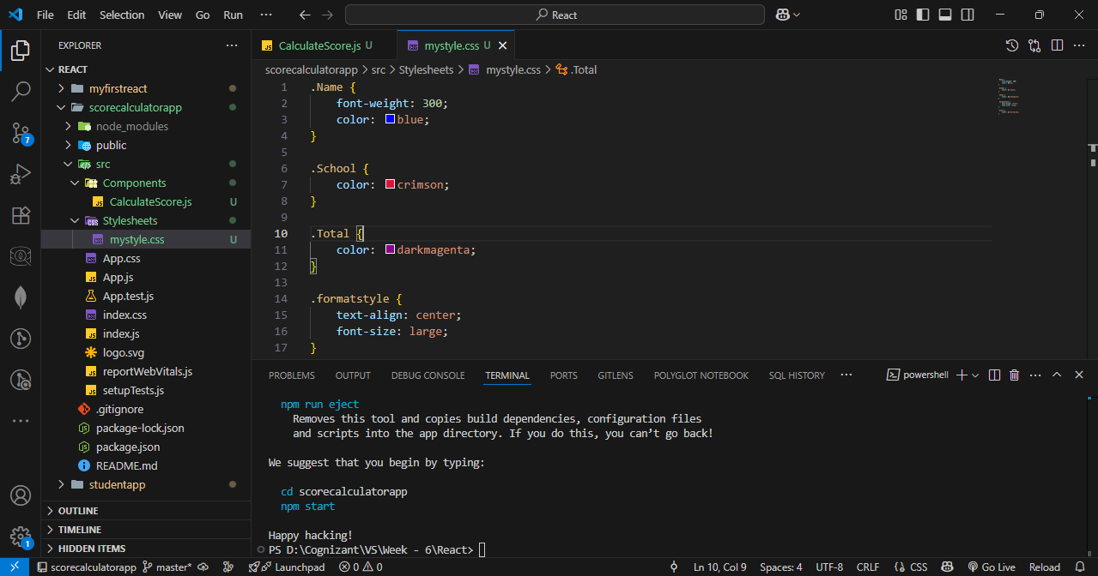

**Step – 4 :** Update app.js code.

**Code :**

import { CalculateScore } from './Components/CalculateScore';

function App() {

  return (

    <div>

      <CalculateScore

        Name={"Hemanth"}

        School={"KL UNiversity"}

        total={284}

        goal={3}

      />

    </div>

  );

}

export default App;

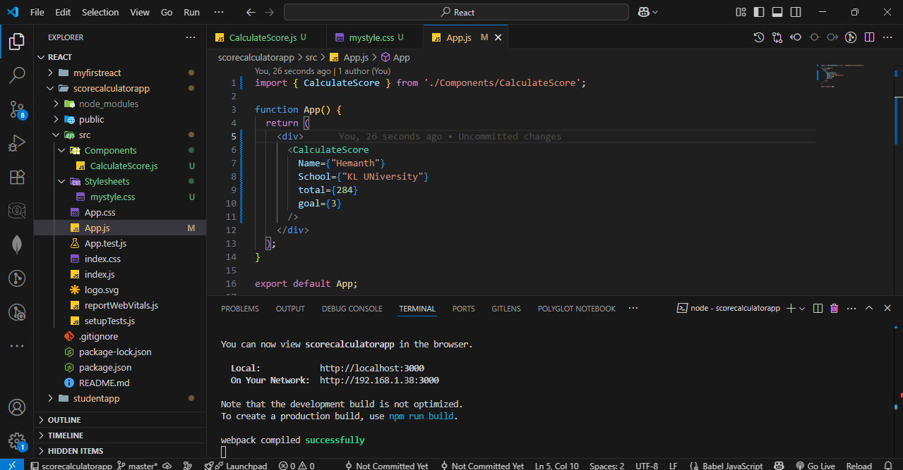

**Step – 5 :** Run the server.



OUTPUT :

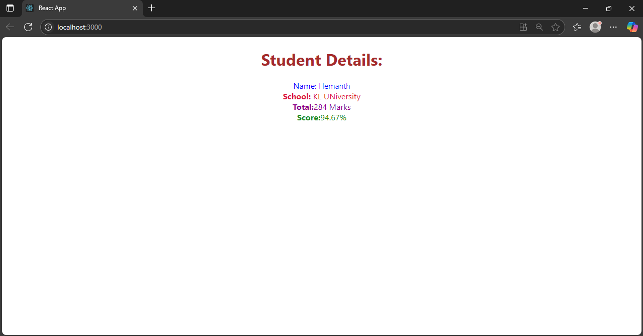

1. Blog App

**Step – 1 :** Create a react app named blog app.

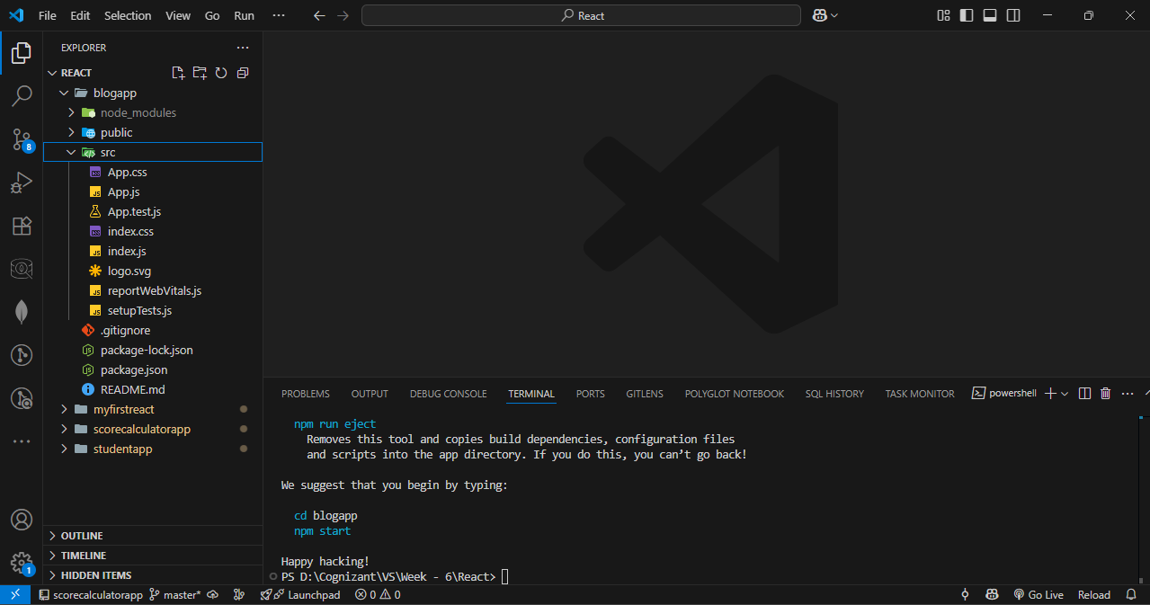

**Step – 2 :** Create posts.js and Post.js in src folder.

**Posts.js Code :**

import React from 'react';

import Post from './Post';

class Posts extends React.Component {

  constructor(props) {

    super(props);

    this.state = {

      posts: [],

      hasError: false

    };

  }

  loadPosts() {

    fetch('https://jsonplaceholder.typicode.com/posts')

      .then((response) => response.json())

      .then((data) => this.setState({ posts: data }))

      .catch((error) => {

        console.error("Fetch Error:", error);

        this.setState({ hasError: true });

      });

  }

  componentDidMount() {

    this.loadPosts();

  }

  componentDidCatch(error, info) {

    alert("An error occurred while rendering posts.");

    console.error("Error caught in componentDidCatch:", error, info);

    this.setState({ hasError: true });

  }

  render() {

    const { posts, hasError } = this.state;

    if (hasError) {

      return <h2>Something went wrong while loading posts.</h2>;

    }

    return (

      <div style={{ padding: '20px' }}>

        <h1>Blog Posts</h1>

        {posts.slice(0, 10).map((post) => (

          <Post key={post.id} title={post.title} body={post.body} />

        ))}

      </div>

    );

  }

}

export default Posts;

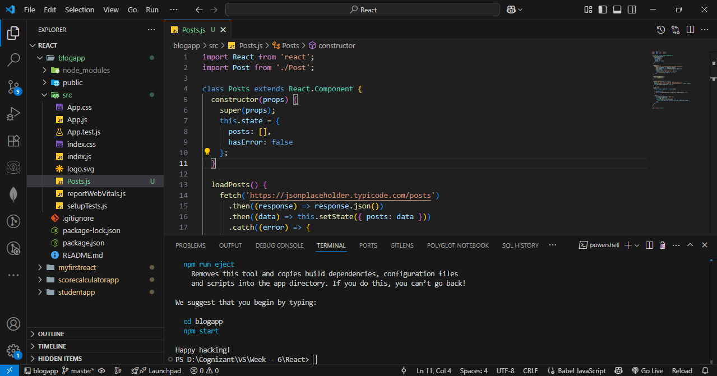

**Post.js Code :**

import React from 'react';

class Post extends React.Component {

  render() {

    const { title, body } = this.props;

    return (

      <div style={{ marginBottom: '20px', padding: '10px', border: '1px solid #ccc' }}>

        <h3>{title}</h3>

        <p>{body}</p>

      </div>

    );

  }

}

export default Post;

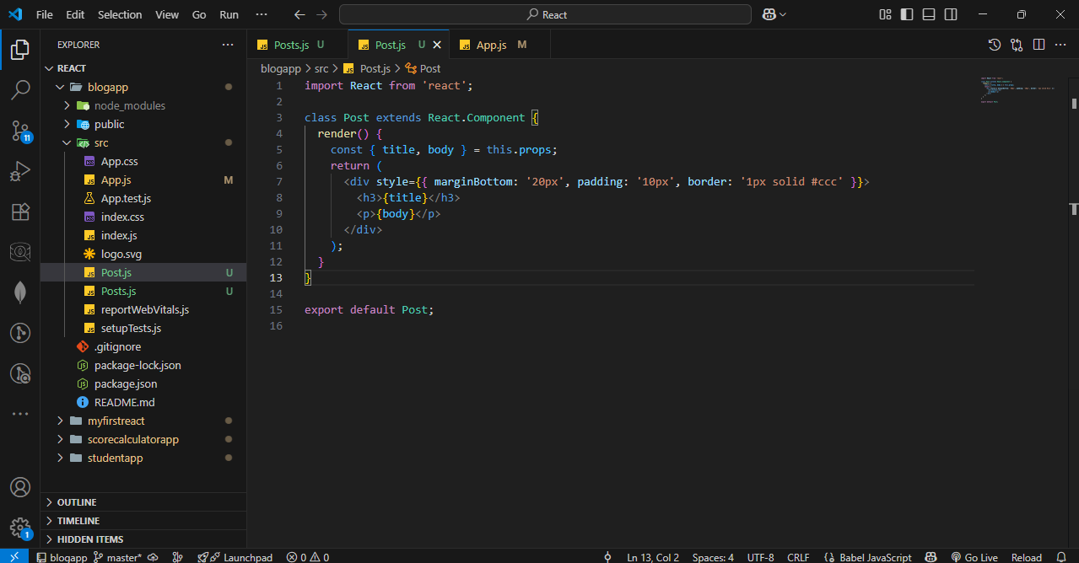

**Step – 3 :** Update app.js

**Code :**

import React from 'react';

import './App.css';

import Posts from './Posts';

function App() {

  return (

    <div className="App">

      <Posts />

    </div>

  );

}

export default App;

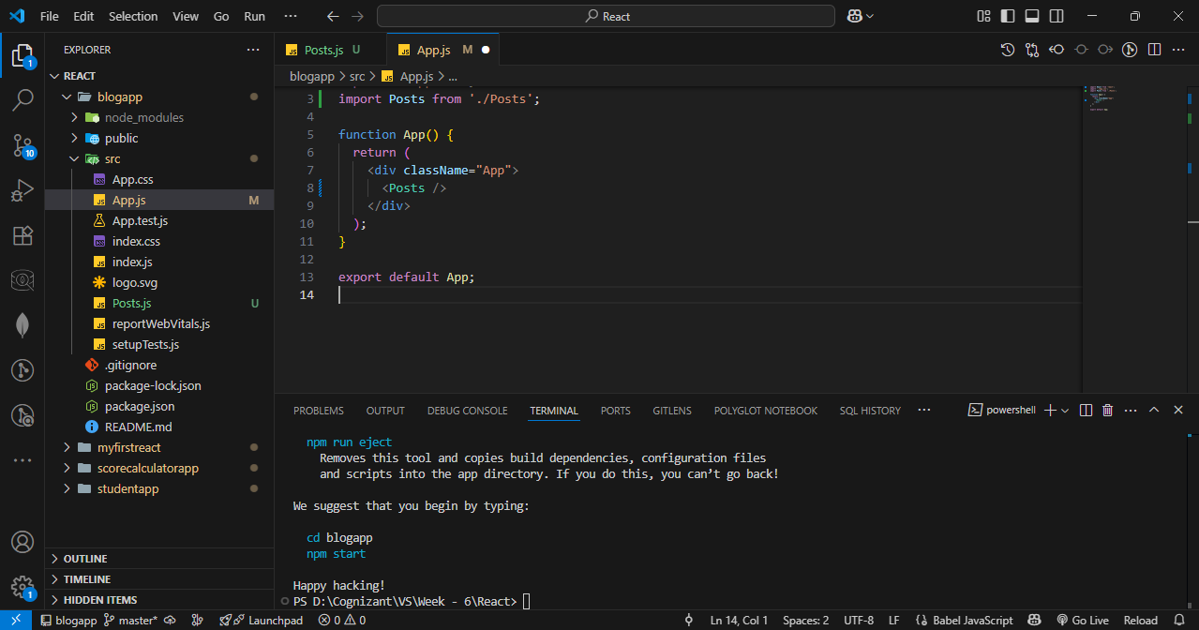

**Step – 3 :** Run the server.

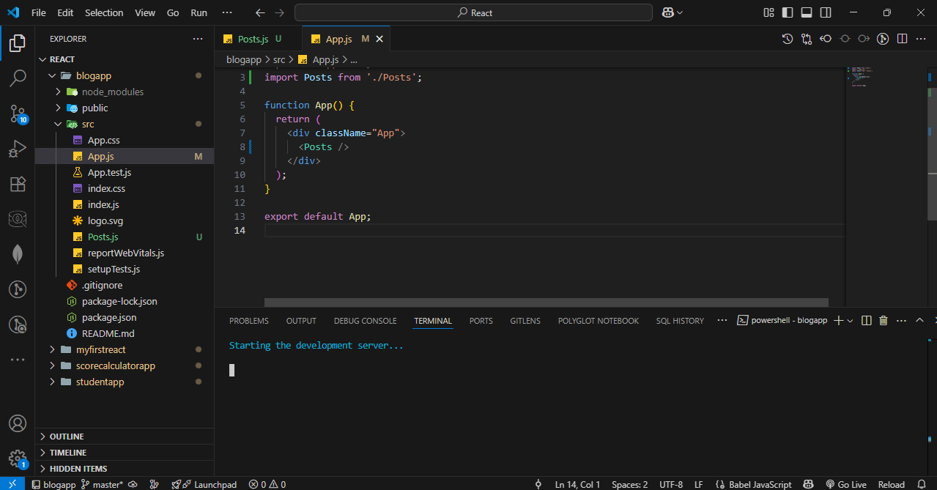

OUTPUT :

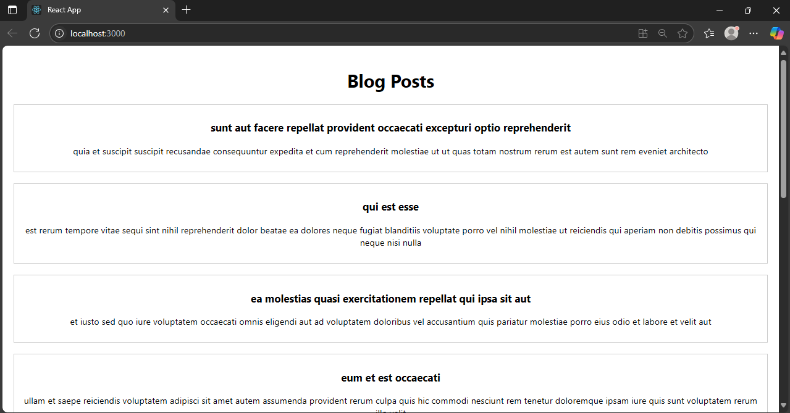

1. Cohort tracker

I cannot find any zip file in the word document. I tried but the only thing I can find is a image which says cohorttracker.zip.

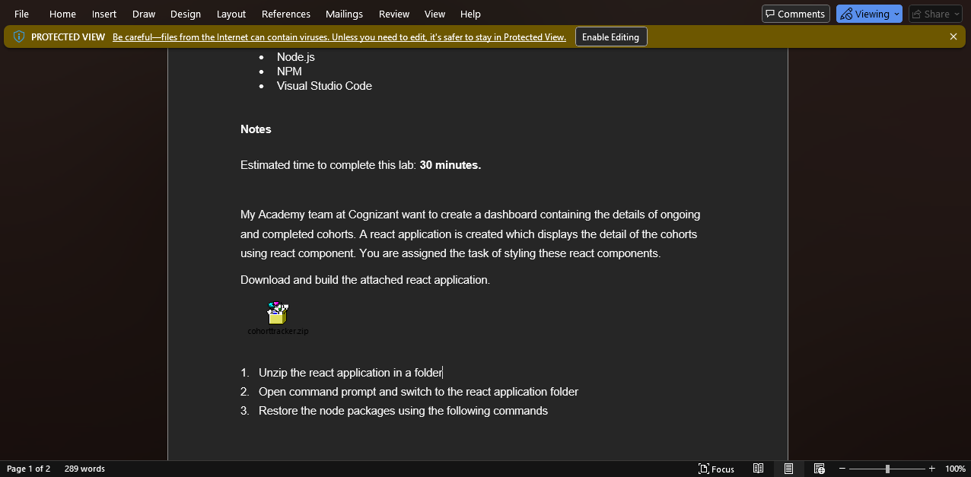

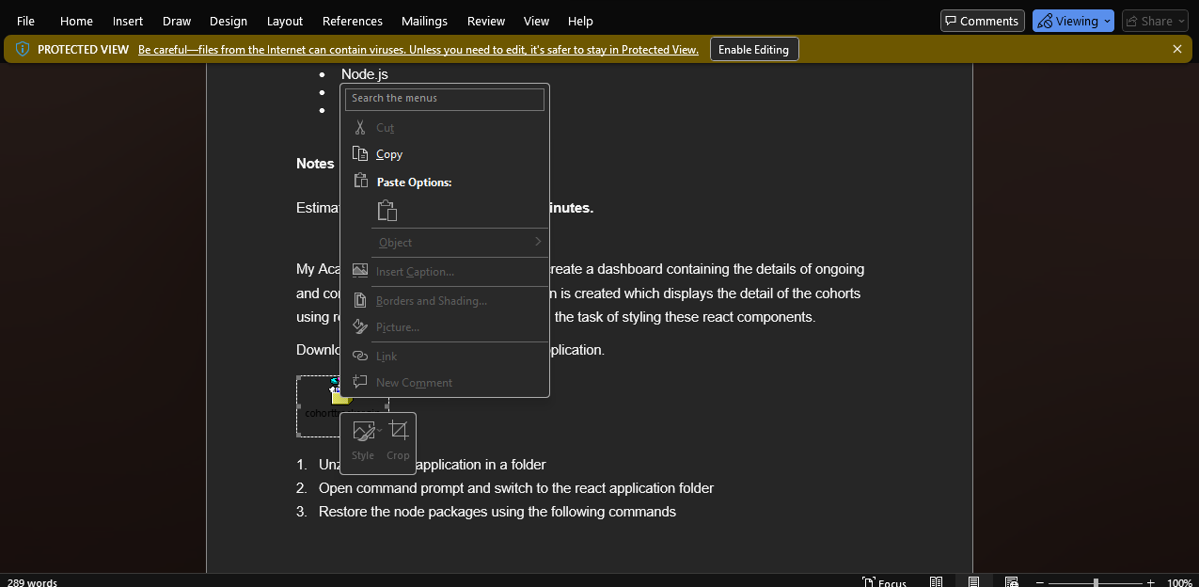

It says it is just a image not a zip file.